## MOCKITY WITH JUNIT WHOLE PRACTICE DOCUMENT

**Problem Statement:**

Create a simple maven project with group id com.in28mins & write a Junit test for the

Truncate A In First 2 Positions method by passing a string & add test case & assertEquals run the test without failure & run successful Junit.

Run a test method that includes before, after, before class & after class methods.

Write a mocks example ToDo service management system & create a unit test using a stub to implement the ToDo service.

Write a test mock list get using BDD in a Given, When & Then style add a delete Todo method in the service interface.

Add the ham crest library dependency to porm.xml & use the assert that method & do ham crest matchers test.

**Solution:**

**Code is present on below path in GITHUB:**

<https://github.com/Raj2020Github/mockito_assessment.git>

Create a simple maven project with group id com.in28mins & write a Junit test for the

truncateAInFirst2Positions method by passing a string & add test case &assertEquals run the test without failure & run successful Junit.

Run a test method that includes before, after, before class & after class methods.

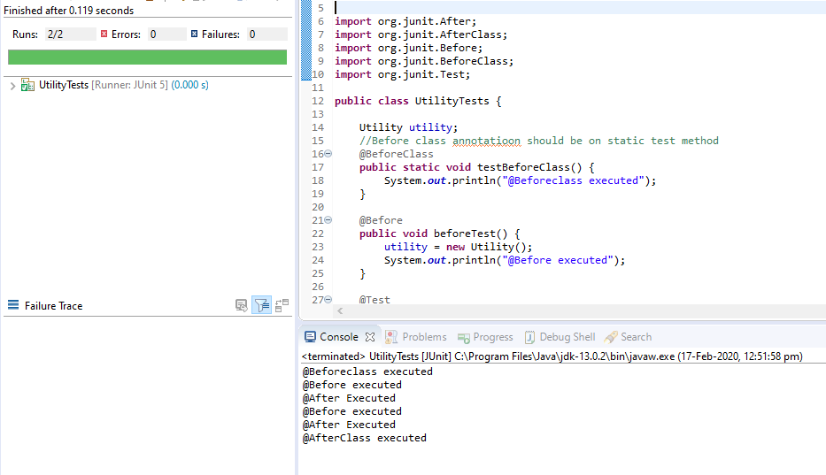

Write a mocks example ToDo service management system & create a unit test using a stub to implement the ToDo service.

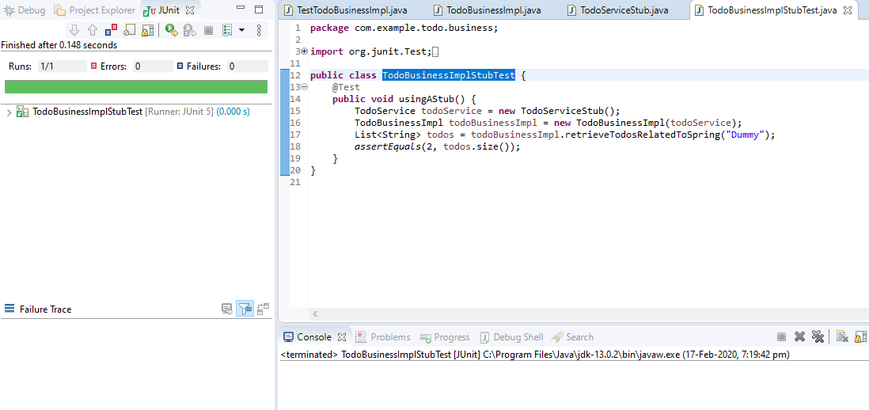

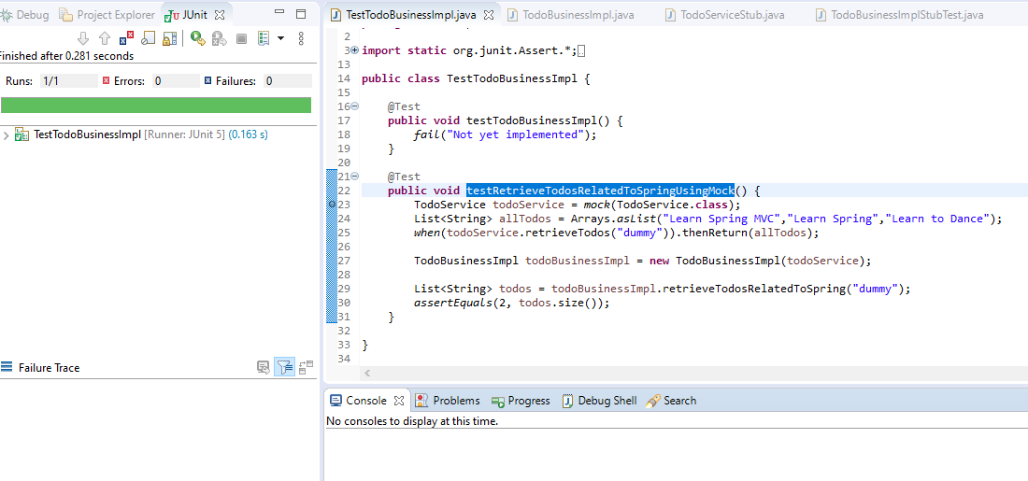

Write a test mock list get using BDD in a Given, When & Then style add a delete Todo method in the service interface.

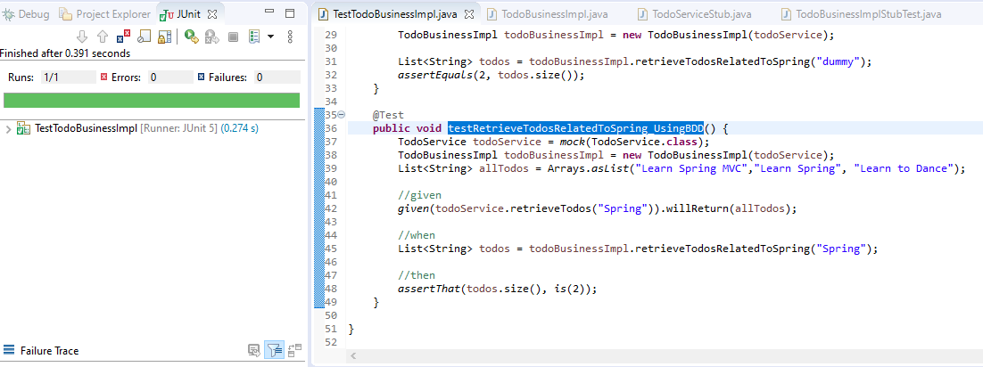

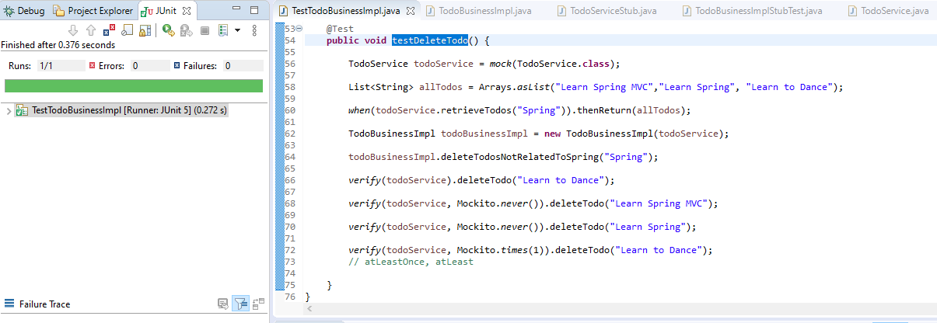

Add the ham crest library dependency to porm.xml & use the assert that method & do ham crest matchers test.

